3.3 Respondent's Opinion on Learning Mode (General)
3.3.1 Do you believe that participating in extracurricular activities or clubs will positively influence your studies?
Frequency table
Answer | Frequency
Strongly Agree (5) | 11
Agree (4) | 24
Neutral (3) | 26
Disagree (2) | 4
Strongly Disagree (1) | 4
TOTAL | 69
Table 3.3.1.1: Frequency table of whether participating clubs will positively influence studies
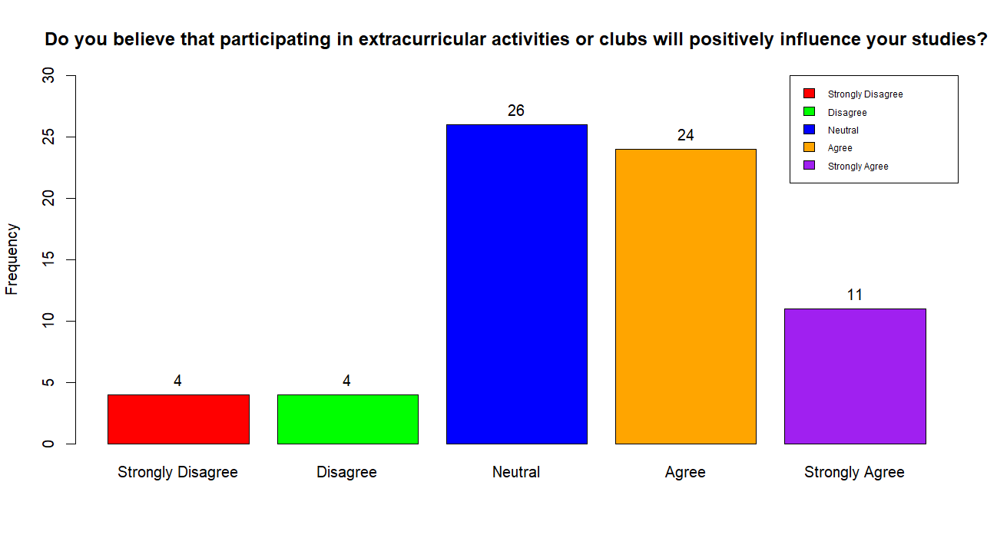
Figure 3.3.1.1: Bar Chart of whether participating clubs will positively influence studies

From table 3.3.1.1 and figure 3.3.1.1 shows that UTM students' opinions on whether extracurricular in positively influencing them. 11 respondents strongly agree, 24 respondents agree, 26 respondents are neutral and only 4 respondents disagree and strongly disagree respectively. From the bar chart, most of the respondents agree that clubs will positively impact their studies as extracurricular activities can helps university students to release stress. However, over participating in clubs’ activities will also lead to unbalanced of studies and activities. Therefore, we should involve in the number of activities in our capability.

3.3.2 Do you agree that past year questions / papers can help a lot in preparations for the exams?
Frequency table
Answer | Frequency
Strongly Agree (5) | 42
Agree (4) | 19
Neutral (3) | 6
Disagree (2) | 1
Strongly Disagree (1) | 1
TOTAL | 69
Table 3.3.2.1: Frequency table of whether past year question will help a lot in exam
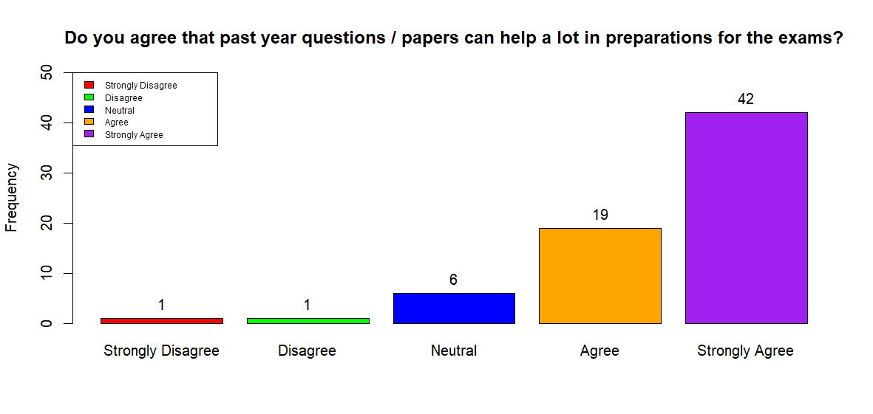
Figure 3.3.2.1: Bar chart of whether past year question will help a lot in exam

According to the data from Table 3.3.2.1 and Figure 3.3.2.1, 42 out of 69 respondents strongly agree that past year question helps a lot in examination. 19 respondents agree while 6 respondents are neutral about it. Otherwise, only 1 respondent disagree and strongly disagree that past year question helps in examination. Through this data, we can analyse that most of the student in UTM do past year question for their preparation for the examination to maintain their academic performances.

3.3.3 How long before the exams you will start practicing on the questions?
Frequency table
Answer | Frequency
One week before exam | 47
5 days before exam | 8
3 days before exam | 12
I don’t do past year question | 2
TOTAL | 69
Table 3.3.3.1: Frequency table of time of practicing on past year question

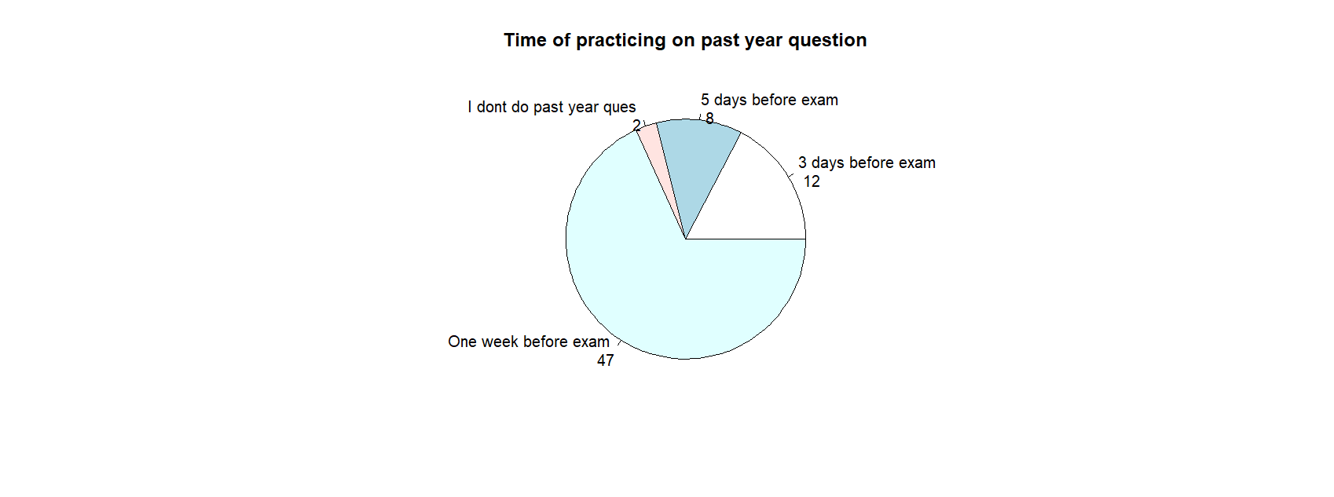
Table 3.3.3.1: Pie chart of time of practicing on past year question

It is about the time taken for respondents to start practicing on question before examination and as shown in Table 3.3.3.1 and Figure 3.3.3.1, approximately 47 out of 69 respondents practicing question one week before exam while 8 respondents practicing 5 days before exam. Furthermore, there are 12 out of 69 respondents practicing 3 days before exam and only 2 respondents which don't do any question before examination. This shows that most of the done more early before the exam to achieve a good academic performance at the end of the semester but there are also some of respondents use only 3 or 5 days to done their practicing on the examination.

3.4 Respondent's result with their own learning mode
3.4.1 What is your CGPA?
Frequency table
Answer | Frequency
3.70 and above | 54
2.70 to 3.69 | 15
1.70 to 2.69 | 0
Below 1.70 | 0
TOTAL | 69
Table 3.4.1.1: Frequency table of time of practicing on past year question

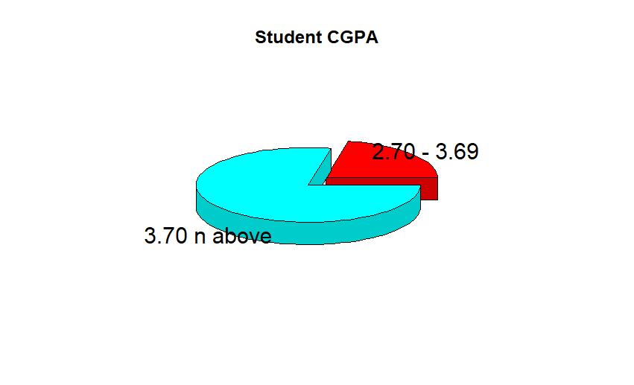
Figure 3.4.1.1: Pie chart of time of practicing on past year question
Based on the data from Table 3.3.4.1 and Figure 3.3.4.1, we can conclude that 54 out of 69 respondents are having CGPA 3.70 and above while 15 respondent are having CGPA from range 2.70 to 3.69. However, there are 0 respondent that having CGPA of range 1.70 to 2.69 and also no respondent having CGPA below 1.70. From this data, we can conclude that most of the student in UTM have their suitable revision style and good time management as they can participate in club without affecting their academic performance. However, there are also some student are lack in those technique as their academic performance is in moderate level. In conclusion, student must have good time planning as they able to perform good in examination while participating in activities.

3.4.2 Are you comfortable with your learning mode right now?
Frequency table
Answer | Frequency
Strongly Agree (5) | 13
Agree (4) | 23
Neutral (3) | 22
Disagree (2) | 9
Strongly Disagree (1) | 2
TOTAL | 69
Table 3.4.2.1: Frequency table of whether comfortable with current learning mode
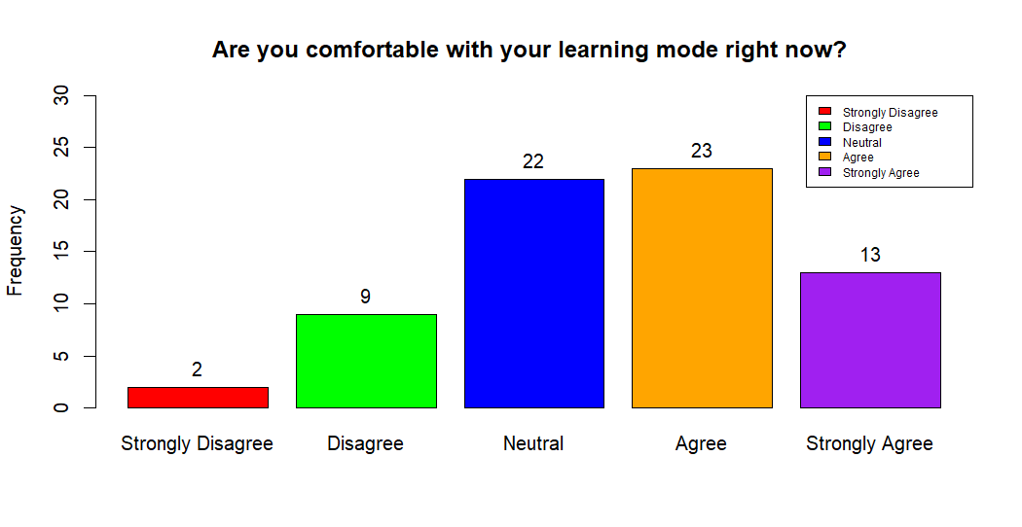
Figure 3.4.2.1: Bar chart of whether comfortable with current learning mode
In the Table 3.4.2.1 and Figure 3.4.2.1 shown that 13 respondent strongly agree about their comfortable with their current learning mode while 23 out of 69 respondents agree about their comfortable with their current learning mode. Moreover, there are 22 respondents who are neutral about this. Furthermore, 9 out of 69 respondents disagree about their comfortable with their learning mode while only 2 respondents are strongly disagree about it. From here, we know that most of the respondents are comfortable with their learning mode and some are neutral. However, there are few of respondents feels uncomfortable with their learning mode which will affect their academic result at the end of the semester. In conclusion, we have to found out the most suitable learning mode to get better result.

3.4.3 Would you consider changing your current learning mode?
Frequency table
Answer | Frequency
Yes | 28
No | 41
TOTAL | 69
Table 3.4.3.1: Frequency table of whether consider changing current learning mode
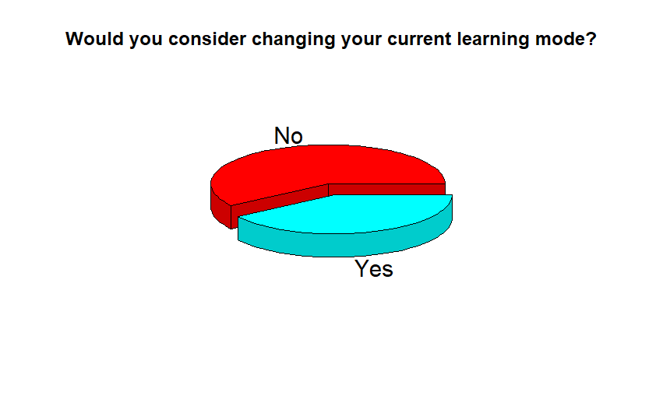
Table 3.4.3.1: Pie chart of whether consider changing current learning mode
Refering to the pie chart above, there are only two choices which is “Yes” or “No”. Most of the respondents which is 41 out of 69 respondents have choose the option “No” as they are comfortable with their study mode and want to remain it. However, there are 28 out of 69 respondents consider to change their current learning mode. This is because their current learning mode are not suitable for them and not getting a better result at the end of semester. In conlusion, we have to change our learning mode immediately when we found out the current learning mode is not suitable for us.

